Vishal Maru

Extra Credit Post: Data Visualization

IT 418 – Dr. Rajeev Bukralia

May 10, 2020

Medium Link: <https://medium.com/@maruvishal35/data-visualization-narrative-for-information-59894b7d6791>

References:

<https://towardsdatascience.com/9-data-visualization-tools-that-you-cannot-miss-in-2019-3ff23222a927>

<https://www.sas.com/en_us/insights/big-data/data-visualization.html>

<https://www.bigskyassociates.com/blog/bid/378479/3-Reasons-Why-Data-Visualization-Is-Critical-To-Your-Enterprise>

Data Visualization: Narrative for Information

Data Visualization is one of those few spaces in the field of Computer Science specifically in Data Science where functionality is added by its beauty. It has a unique ability to take the vast complicated sets of data and show the desired trends, information, patterns, etc. to its audience in the most comprehendible ways possible. It is an essential tool in an era where the amount of information is increasing exponentially, and the attention span of a person can be lost in under 10 seconds.

When an executive who needs to make fast decisions in order to earn the most possible amount of profit enters the same equation, it becomes very non-compelling to the presenter to just throw a bunch a words and numbers. Especially, when you have powerful data visualization tools like D3.JS, Tableau, Vega, Power BI, etc.

What Data visualization does, is it takes down the amount of required time to explain the information to a minimum while making it as easy as possible to comprehend it. Consider this example, first, only look at A, try to understand it and make a meaning behind it, then do the same with B. Keep in mind the time taken for both of these exercises.

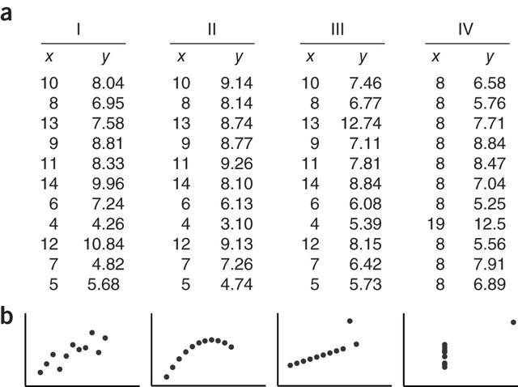

Even without much knowledge in Math and Statistics, the common trends and patterns of the data require significantly less time and are much easier to understand in example B than in example A. Now, consider the difficulty if it was not just ten rows but ten thousand rows of data, let alone millions and billions that the growing technology industry is bringing in.

A lot of this has to do with visual memory and comprehension. Addition of graphs, heatmaps, charts, various new three-dimensional visual elements, etc. along colors, style, dimensionality, etc. brings better interaction with viewer and the data without ever having the user look at actual numbers or the data.

Because of these strengths and abilities of Data visualization, it is undoubtedly an intriguing and heavily important aspect of Data Science which brings compelling storytelling to the rapidly new growing world of ones and zeros.